**FIT3179 Data Visualisation 2**

**Capital Flow of the World**

**Prepared by:**

Bryan Jun Kit Wong

32882424

1062 words (excluding cover, figures and references)

**Visualisation URL:**

<https://wongjunkit12.github.io/Assignment-2/>

**Github URL:**

<https://github.com/Wongjunkit12/Assignment-2>

**Domain**

This visualisation centres around the movement of capital between countries through global trade via imports and exports of goods.

**Why?**

This visualisation holds significant appeal for the average user by providing a window into the dynamics of trade and the interconnectedness of the global economy. Users can gain a deeper understanding of international economic trends, trade balances and the relative economic strength of countries.

**Who?**

This visualisation is relevant to a wide audience - business professionals seeking market insights, economists studying trade trends, policymakers shaping economic policies, educators using real-world examples, the general public interested in trade's impact on daily life and investors assessing international markets.

**What?**

This visualisation uses three datasets. The main dataset is the world export and import dataset (Awan, 2023), which is scraped from various reliable sources. The second dataset is the world GDP (Tas, 2022) by the World Bank. Lastly, the third dataset is the latitude and longitude for every country (Mooney, 2020) taken from Google Maps. All the data are normalised to US$ Billions and some countries are excluded due to missing or inconsistent data.

**Why and How?**

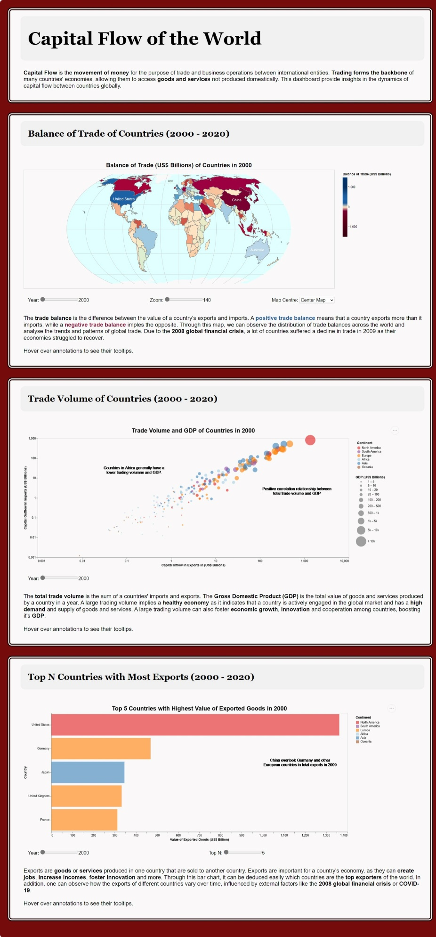

Figure 1.1: The entire Data Visualisation.

**Choropleth Map**

Figure 2.1: Choropleth Map depicting Trade Balances of Countries from 2000 - 2020.

Figure 2.2: Interactive and dynamic tooltips for annotated countries

The choropleth map idiom in Figure 2.1 was chosen to illustrate the variation of trade balances across different countries and continents. In addition, the user can compare the relative economic performance of different regions with ease, enabling them to identify patterns and trends over time. For example, the user can see that Africa and South America generally have lower balances of trade in comparison to Europe and Asia. The map also has a multitude of features such as a year filter slider, which allows the user to track temporal changes, while interactive tooltips (Figure 2.2) provide detailed information when hovering over the annotations or countries on the map. Zooming and centring features are provided, catering to a more detailed exploration of the data. The colour legend is colour-blind friendly, allowing the user to instantly distinguish which country has a trade surplus or deficit.

**Bubble Plot**

Figure 3.1: Bubble Plot depicting the Total Trade Volume of Countries and their GDP.

Figure 3.2: Custom tooltips which provides detailed elaborations on text annotations.

The bubble plot in Figure 3.1 depicts the relationship between trade and GDP across different countries and continents. Through this, user can compare the economic significance of trade on their economy for different nations, identifying outliers and clusters in the process all within an intuitive view. For example, China has the highest total trade volume, as well as an incredibly large GDP, while some African countries have minuscule GDP along with minute trade volumes. Continents are colour-coded in the legend, simplifying the recognition of regional trade and economic patterns. They can also be selected to highlight data from specific continents. Similar to Figure 2.2, Figure 3.2 shows dynamic custom tooltips for the annotations, which provide detailed elaborations on text annotations. Furthermore, the bubble plot has a year slider filter, allowing users to explore the data across various time frames and identify trends.

**Bar Chart**

Figure 4.1: Bar chart representing the Top N countries with most value of exports.

Figure 4.2: Custom tooltips which provides detailed elaborations on text annotations.

Figure 4.1 displays a bar chart which showcases the ranking of different countries based on their value of exported goods. This allows the user to make easy comparisons between different countries, enabling them to detect outliers or gaps between different countries. In this case, the user can see a large discrepancy between the US and Germany, showcasing the differences in the countries’ trading focuses. A year slider is also incorporated for temporal analysis, enabling users to track changes in the rankings over the years and gain insights into how trade dynamics have evolved. Additionally, the chart features a "Top N" filter, permitting users to customise the number of countries displayed, catering to their specific analytical needs. Similar to Figure 3.1 continents are color-coded in the legend, which can be selected to highlight certain continents. Likewise, annotations provide further elaborate descriptions when hovered over as shown in Figure 4.2

**Design**

**Layout**

To align to storytelling principles, the title and subtitle are left-aligned as users read from left to right, top to bottom. Meaning titles and subtitles are placed above each idiom, with corresponding explanations and text below the idiom. This approach ensures the visual centre for each section is the idiom itself. The visualisation elements were meticulously aligned along both invisible horizontal and vertical sightlines, ensuring a balanced visualisation.

**Colour**

A consistent colour-blind palette was painstakingly chosen, aiming to enhance comprehension. Colour consistency in annotations and text fosters coherence and aids users in associating specific elements within the various idioms, such as in the Choropleth Map annotations. Furthermore, high colour contrast helps differentiate the various data within the idiom.

**Figure-ground**

Figure 5.1: Asia is selected.

Figure 5.1 shows Asia being selected. This action causes all other continents to recede into the background, creating a subdued appearance. This approach emphasises the chosen option while minimising distractions from the unselected elements.

Backgrounds within each section remained a neutral white to ensure the idioms and other essential elements like annotations stood out prominently. This contrast creates a visual distinction that directs users' eyes to the most pertinent aspects of the visualisation. Certain words in the text are bolded to provide additional emphasis on specific information. This technique contributes to enhanced clarity and draws attention to vital details within the visualisation.

To enhance readability and emphasis, titles and subtitles are rendered in a larger, bolded font style compared to other text. This deliberate differentiation aids in highlighting the critical components of the visualisation and makes them more prominent to the user.

**Typography**

Serif typeface is chosen for certain text elements like the title and subtitles whereas Sans-serif fonts were chosen for graphical elements like the description text and graph annotations. A difference in typeface is employed to enhances the visual hierarchy, with Serif fonts offering a classic and refined appearance for important titles, and Sans-Serif fonts providing a modern, clean look for secondary, less important text. The text layout employed ample spacing and alignment, creating structured and organised visual presentation, ensuring that users can easily absorb the information.

**Storytelling**

Reader guidance was achieved through a sequential narrative. Idioms were introduced logically, starting with a broad map showcasing the balance of trade of different countries in Figure 2.1, to Figure 4.1, where a bar chart was introduced to specifically highlight the top exporters, allowing users to grasp the dynamics of international trade and economic performance in a ranked context. Annotations accompanied by concise explanations in tooltips directed attention to significant data points or outliers. Figure-ground elements are used liberally to guide the reader’s attention to critical information. Filtering options are provided to enable users to interact with the data, creating a coherent and insightful story.

**Bibliography/list of references**

Awan, M. T. (2023). *World Export & Import Dataset (1989 - 2023)*. Retrieved from <https://www.kaggle.com/datasets/muhammadtalhaawan/world-export-and-import-dataset>

Mooney, P. (2020, March 13). *Latitude and longitude for every country*. <https://www.kaggle.com/datasets/paultimothymooney/latitude-and-longitude-for-every-country-and-state>

Tas, O. C. (2022). *World GDP*. Retrieved from <https://www.kaggle.com/datasets/zgrcemta/world-gdpgdp-gdp-per-capita-and-annual-growths?select=gdp.csv>

**Appendix**

**Five Design Sheets**

**Sheet 1**

Figure 6.1: 5DS Sheet 1

**Sheet 2**

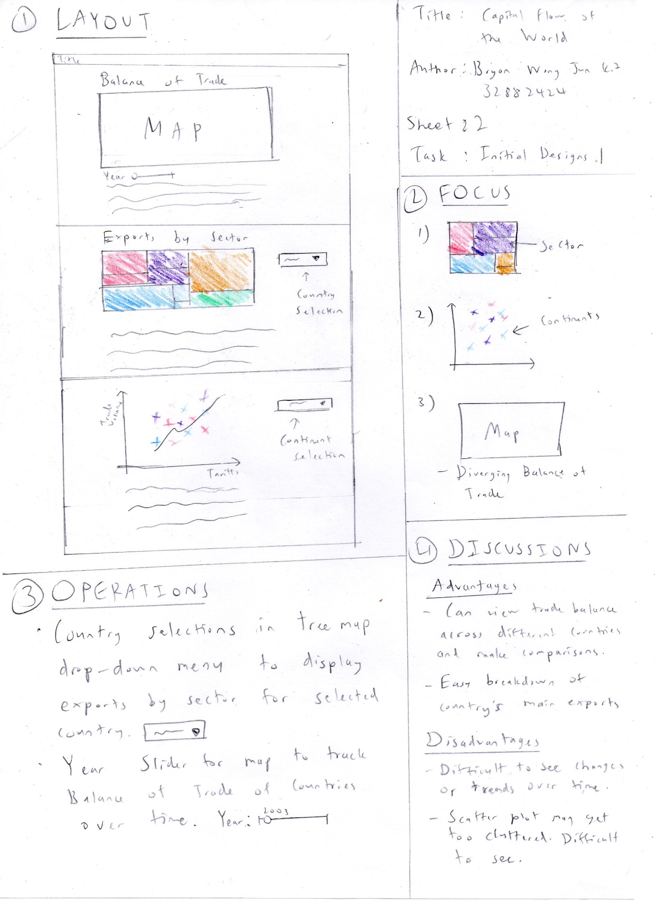

Figure 6.2: 5DS Sheet 2

**Sheet 3**

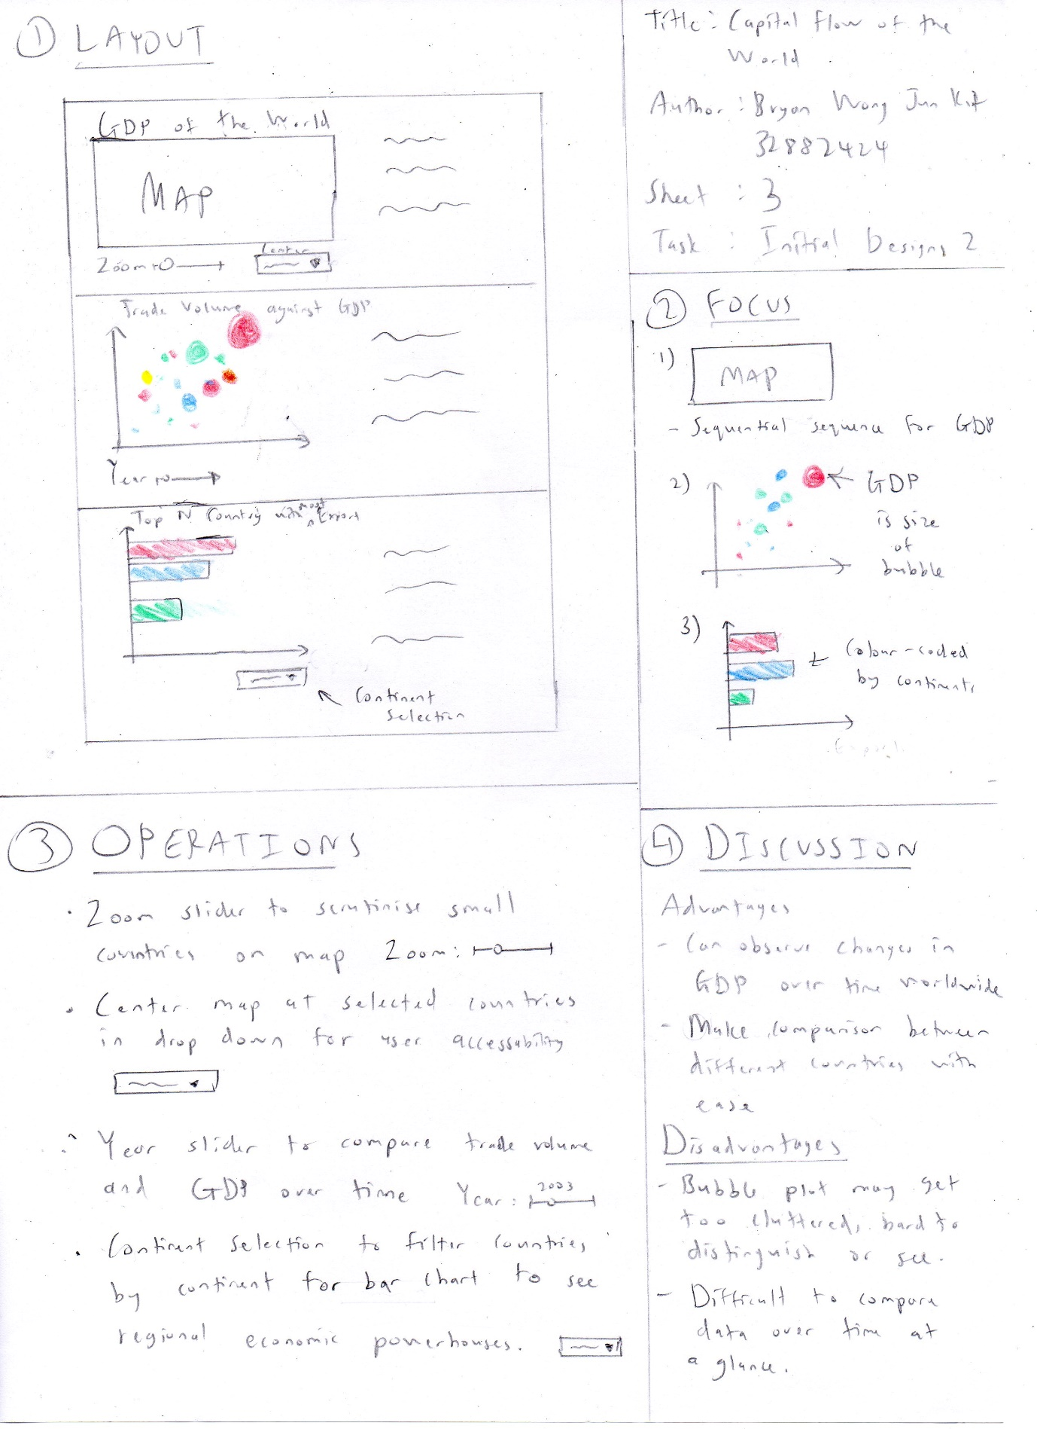

Figure 6.3: 5DS Sheet 3

**Sheet 4**

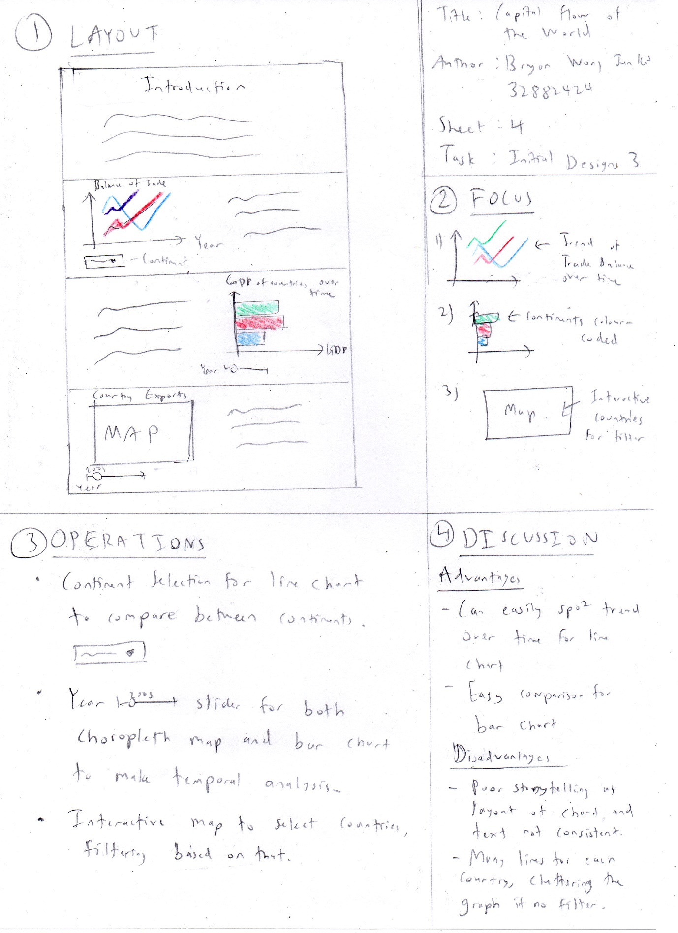

Figure 6.4: 5DS Sheet 4

**Sheet 5**

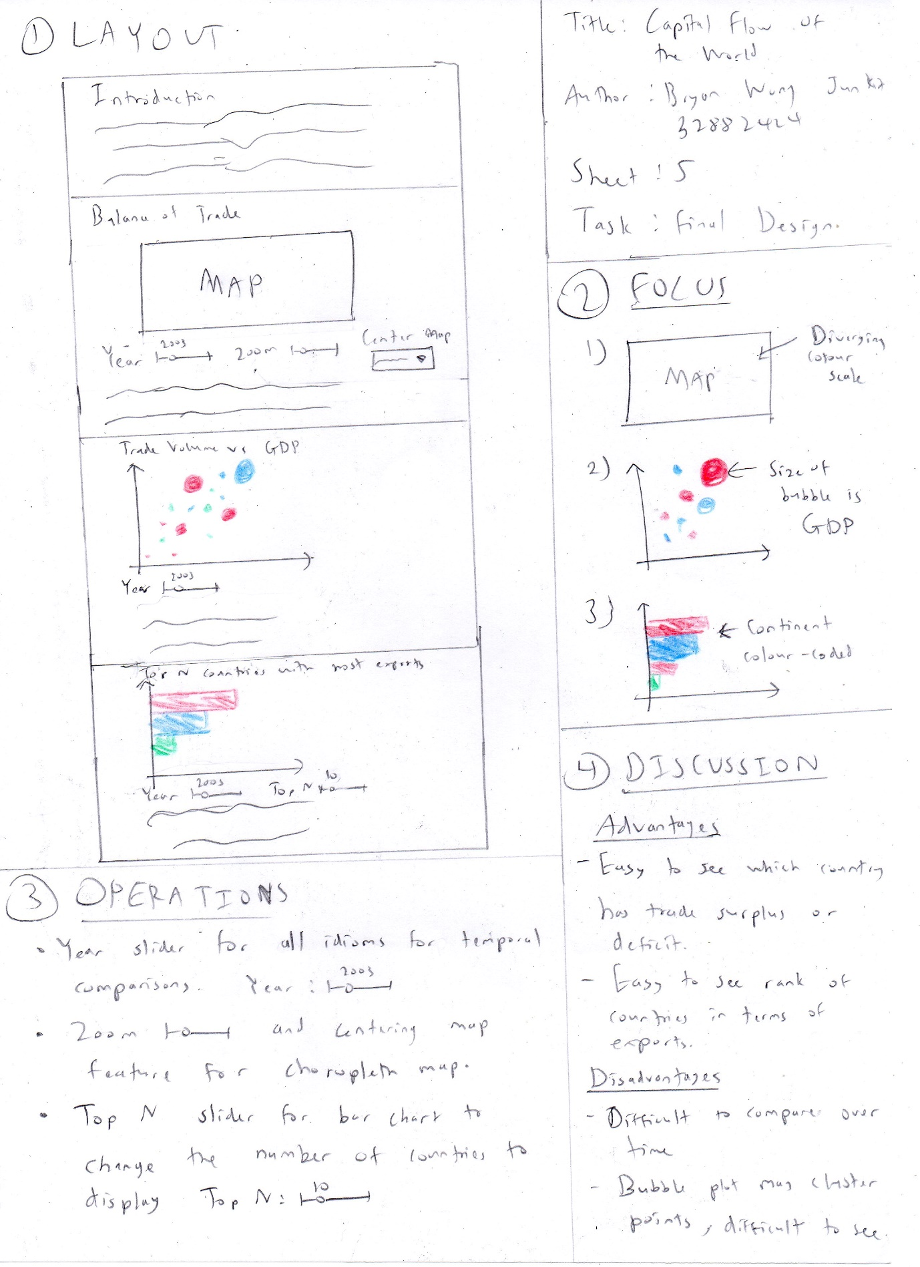

Figure 6.5: 5DS Sheet 5